MANAV RACHNA INTERNATIONAL INSTITUTE OF RESEARCH AND STUDIES

ASSIGNMENT SHEET

SUBJECT NAME: WEB TECHNOLOGY

SUBJECT CODE:4.5CA101C01 PP

ROLL NO – 24/SCA/BCA/017

FULL NAME--HIND TEWATIA

DEPARMENT—SCA(SCHOOL OF COMPUTER APPLICATIONS)

PROGRAM NAME- BCA

SECTION- A

1 . Create a simple HTML page using basic tags.

<!DOCTYPE html>

<html lang="en">

<head>

<meta charset="UTF-8">

<meta name="viewport" content="width=device-width, initial-scale=1.0">

<title>Simple HTML Page</title>

</head>

<body>

<header>

<h1>Welcome to My Simple Web Page</h1>

</header>

<section>

<h2>About Me</h2>

<p>Hello! I'm a beginner web developer, and this is a simple HTML page. I'm learning HTML to create beautiful websites!</p>

</section>

<section>

<h2>

2 . Create a web page that displays your name to the screen.

<!DOCTYPE html>

<html lang="en">

<head>

<meta charset="UTF-8">

<meta name="viewport" content="width=device-width, initial-scale=1.0">

<title>Display Name</title>

</head>

<body>

<h1>Hello, my name is hind!</h1>

</body>

</html>

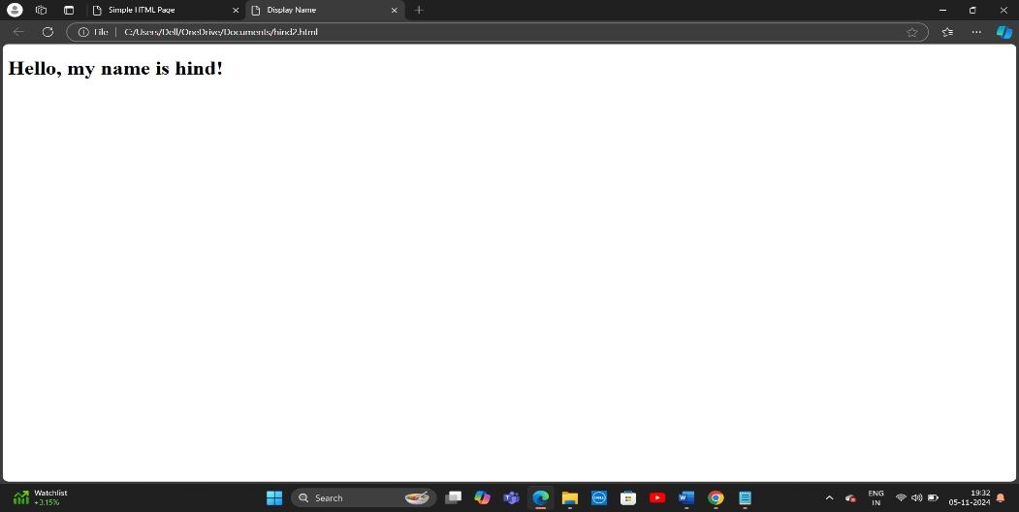

3 .Create a web page and show the output from 1 to 10 in separate lines.

<!DOCTYPE html>

<html lang="en">

<head>

<meta charset="UTF-8">

<meta name="viewport" content="width=device-width, initial-scale=1.0">

<title>Numbers from 1 to 10</title>

</head>

<body>

<h1>Numbers from 1 to 10</h1>

<p>1</p>

<p>2</p>

<p>3</p>

<p>4</p>

<p>5</p>

<p>6</p>

<p>7</p>

<p>8</p>

<p>9</p>

<p>10</p>

</body>

</html>

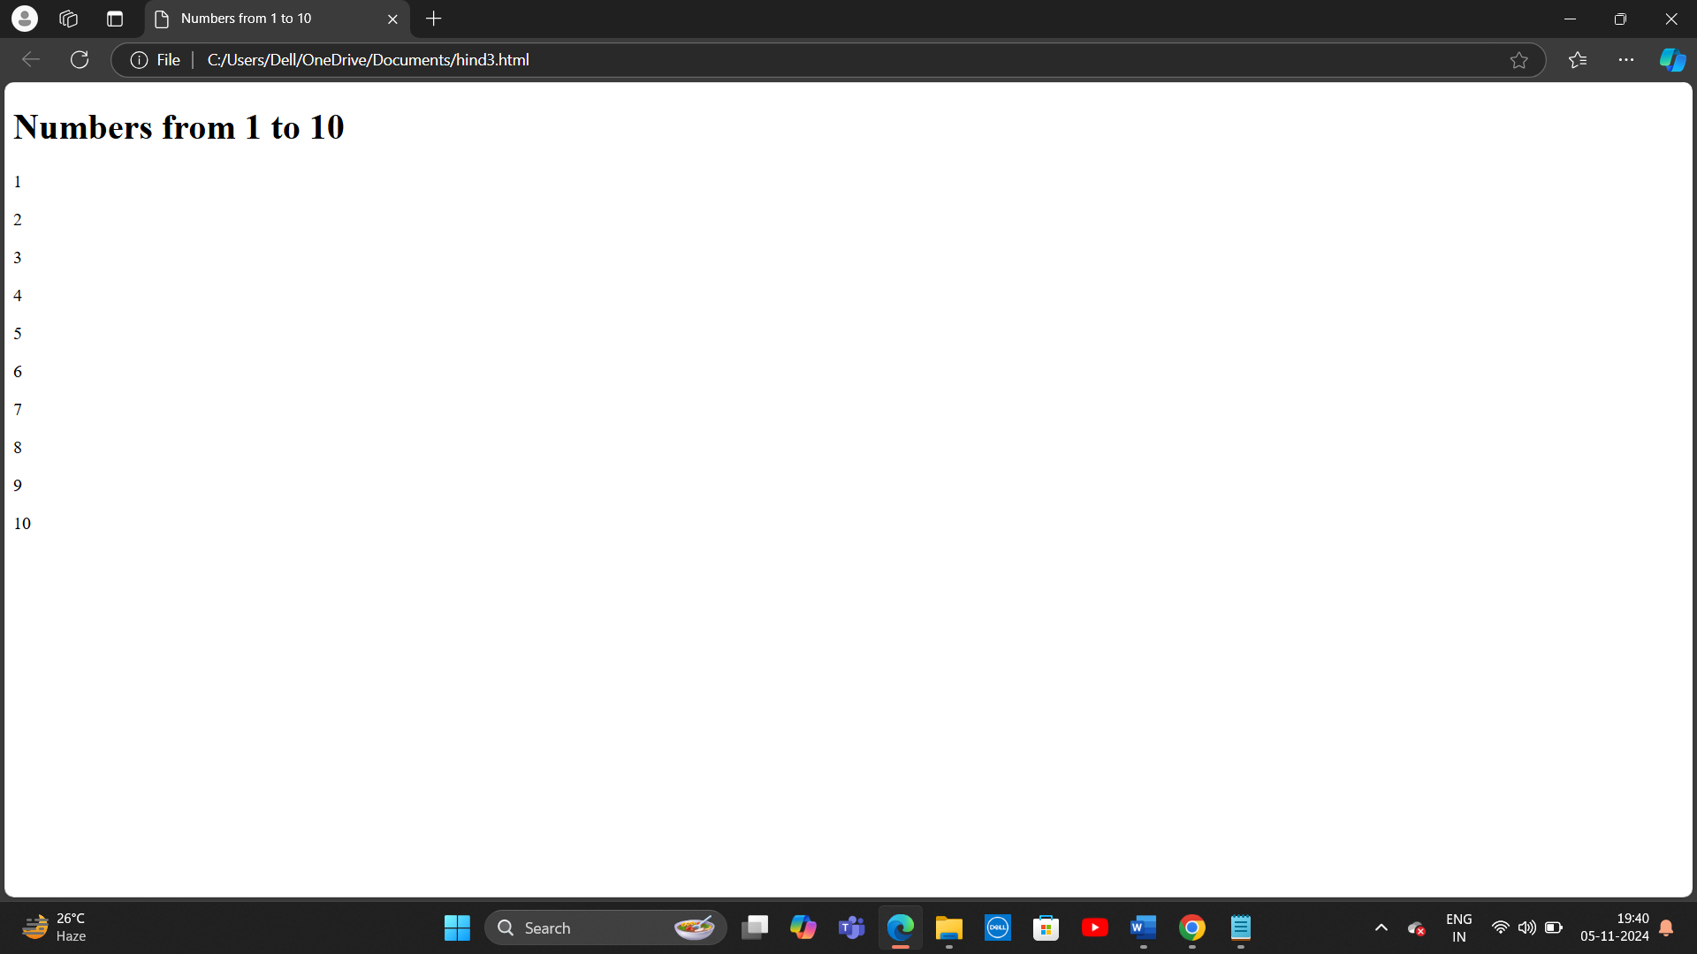

4. Create a web page and show the output from 1 to 10 in separate lines, each number being in different color.

<!DOCTYPE html>

<html lang="en">

<head>

<meta charset="UTF-8">

<meta name="viewport" content="width=device-width, initial-scale=1.0">

<title>Colored Numbers from 1 to 10</title>

<style>

/* Assigning different colors to each number */

.number1 { color: red; }

.number2 { color: green; }

.number3 { color: blue; }

.number4 { color: purple; }

.number5 { color: orange; }

.number6 { color: pink; }

.number7 { color: yellow; }

.number8 { color: brown; }

.number9 { color: teal; }

.number10 { color: cyan; }

</style>

</head>

<body>

<h1>Colored Numbers from 1 to 10</h1>

<p class="number1">1</p>

<p class="number2">2</p>

<p class="number3">3</p>

<p class="number4">4</p>

<p class="number5">5</p>

<p class="number6">6</p>

<p class="number7">7</p>

<p class="number8">8</p>

<p class="number9">9</p>

<p class="number10">10</p>

</body>

</html>

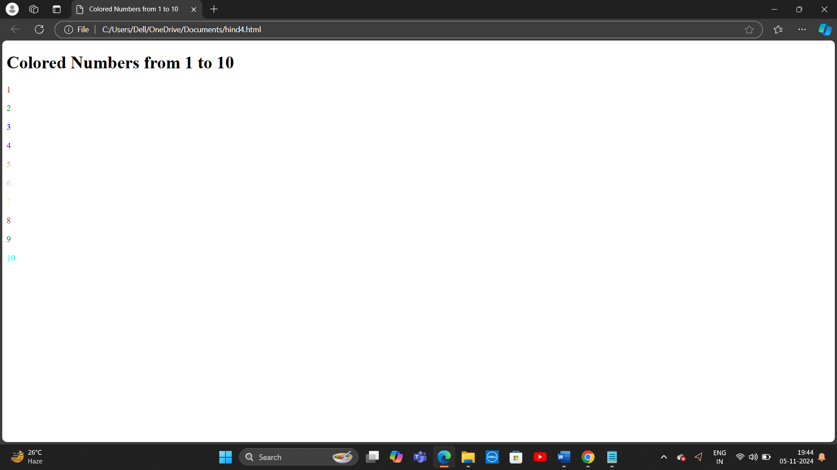

5. How do I make a picture as a background on my web pages?

<!DOCTYPE html>

<html lang="en">

<head>

<meta charset="UTF-8">

<meta name="viewport" content="width=device-width, initial-scale=1.0">

<title>Background Image Example</title>

<style>

body {

background-image: url('https://via.placeholder.com/1500'); /* Example placeholder image */

background-size: cover;

background-position: center;

background-repeat: no-repeat;

height: 100vh;

margin: 0;

}

</style>

</head>

<body>

<h1>Welcome to My Web Page!</h1>

<p>This page has a background image from the web.</p>

</body>

</html>

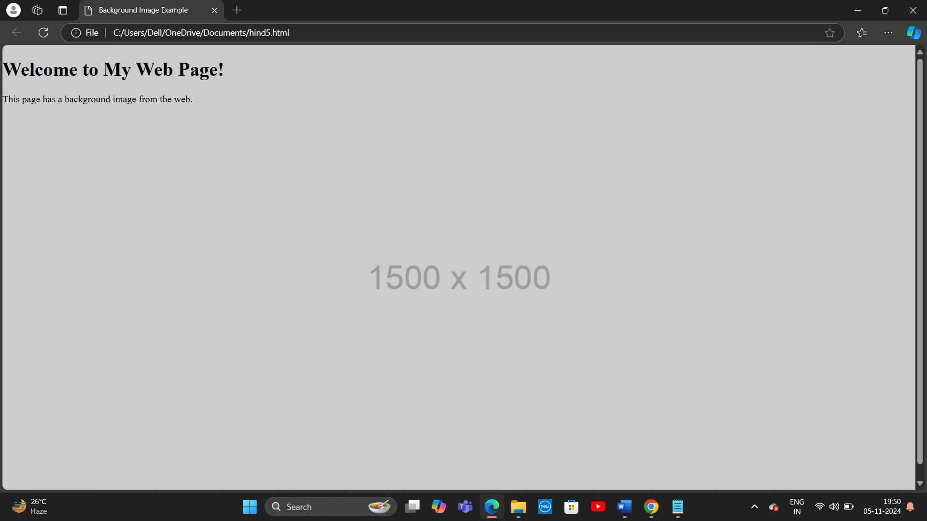

6. Create a web page to print a paragraph with 4-5 sentences, each sentence shall have a different font.

<!DOCTYPE html>

<html lang="en">

<head>

<meta charset="UTF-8">

<meta name="viewport" content="width=device-width, initial-scale=1.0">

<title>Paragraph with Different Fonts</title>

<style>

/* Styling for different sentences with different fonts */

.sentence1 {

font-family: 'Arial', sans-serif;

font-size: 16px;

}

.sentence2 {

font-family: 'Courier New', Courier, monospace;

font-size: 16px;

}

.sentence3 {

font-family: 'Times New Roman', Times, serif;

font-size: 16px;

}

.sentence4 {

font-family: 'Georgia', serif;

font-size: 16px;

}

.sentence5 {

font-family: 'Verdana', sans-serif;

font-size: 16px;

}

</style>

</head>

<body>

<h1>Paragraph with Different Fonts</h1>

<p>

<span class="sentence1">This is the first sentence using the Arial font.</span>

<span class="sentence2">Here comes the second sentence, in Courier New font.</span>

<span class="sentence3">This third sentence is written in Times New Roman.</span>

<span class="sentence4">The fourth sentence uses the Georgia font style.</span>

<span class="sentence5">Finally, this is the fifth sentence in Verdana font.</span>

</p>

</body>

</html>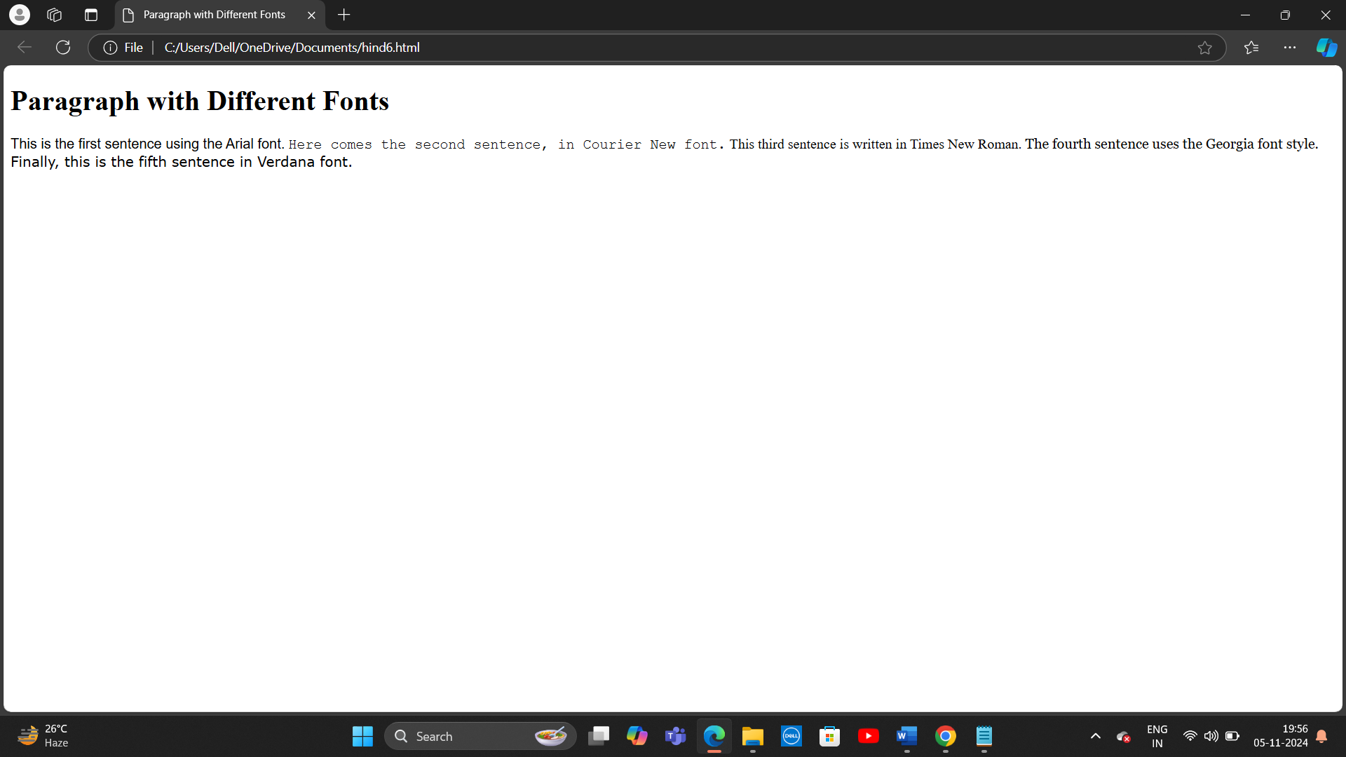

6. Write HTML code to print a paragraph that is description of a book, it shall include the title of the book, its author name; name and title should be underlined and all adjectives shall be bold and Italics

<!DOCTYPE html>

<html lang="en">

<head>

<meta charset="UTF-8">

<meta name="viewport" content="width=device-width, initial-scale=1.0">

<title>Book Description</title>

<style>

/* Underline the title and author */

.underlined {

text-decoration: underline;

}

/* Style adjectives in bold and italic */

.adjective {

font-weight: bold;

font-style: italic;

}

</style>

</head>

<body>

<h1>Book Description</h1>

<p>

<span class="underlined">The Great Gatsby</span> is a <span class="adjective">captivating</span> novel by the renowned author <span class="underlined">F. Scott Fitzgerald</span>. The story is set in the <span class="adjective">roaring</span> 1920s and follows the <span class="adjective">mysterious</span> Jay Gatsby and his <span class="adjective">unrequited</span> love for Daisy Buchanan. The book explores themes of <span class="adjective">wealth</span>, <span class="adjective">ambition</span>, and the <span class="adjective">American</span> Dream, making it a <span class="adjective">timeless</span> classic in American literature.

</p>

</body>

</html>

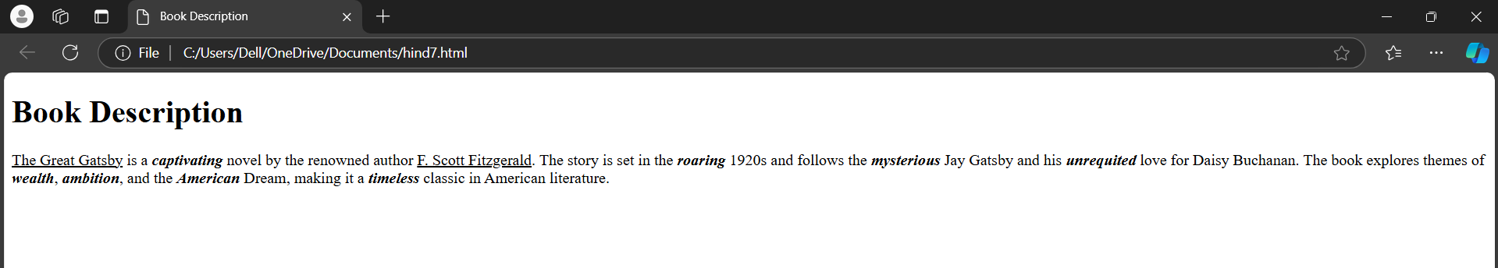

7. Write HTML code to print your name using Heading tag, every letter shall be of different heading size.

<!DOCTYPE html>

<html lang="en">

<head>

<meta charset="UTF-8">

<meta name="viewport" content="width=device-width, initial-scale=1.0">

<title>Different Heading Sizes</title>

</head>

<body>

<h1>C</h1>

<h2>h</h2>

<h3>a</h3>

<h4>t</h4>

<h5>G</h5>

<h6>P</h6>

<h1>T</h1>

</body>

</html>

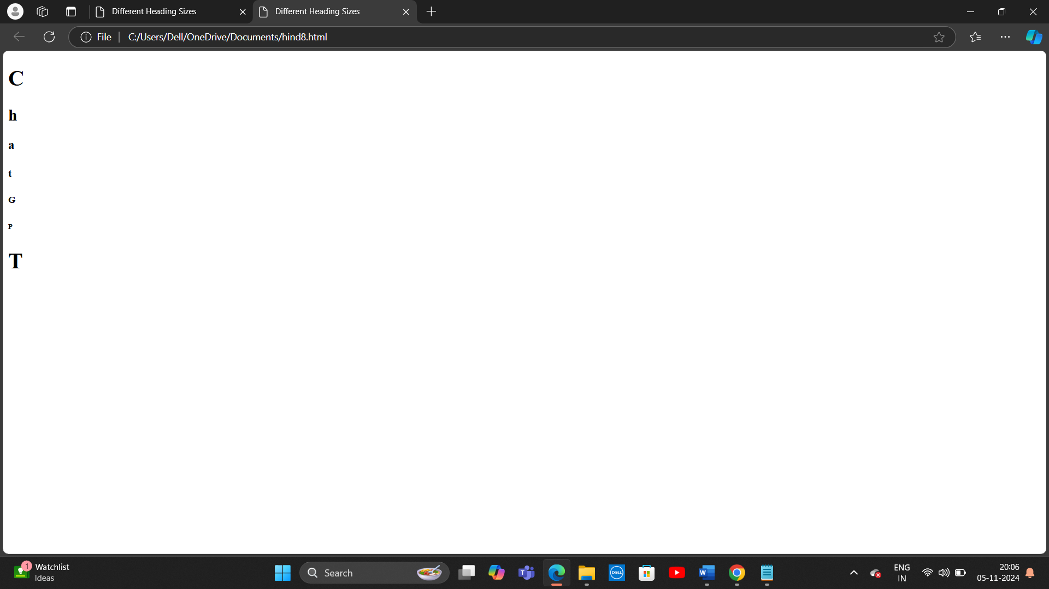

9. Write HTML code to print the sequence of numbers 1-20. Each number shall be in different line with number 2 next to it as subscript, an equal sign and the result.

<!DOCTYPE html>

<html lang="en">

<head>

<meta charset="UTF-8">

<meta name="viewport" content="width=device-width, initial-scale=1.0">

<title>Number Sequence with Squares</title>

</head>

<body>

<h1>Number Sequence with Squares</h1>

<p>1<sub>2</sub> = 1</p>

<p>2<sub>2</sub> = 4</p>

<p>3<sub>2</sub> = 9</p>

<p>4<sub>2</sub> = 16</p>

<p>5<sub>2</sub> = 25</p>

<p>6<sub>2</sub> = 36</p>

<p>7<sub>2</sub> = 49</p>

<p>8<sub>2</sub> = 64</p>

<p>9<sub>2</sub> = 81</p>

<p>10<sub>2</sub> = 100</p>

<p>11<sub>2</sub> = 121</p>

<p>12<sub>2</sub> = 144</p>

<p>13<sub>2</sub> = 169</p>

<p>14<sub>2</sub> = 196</p>

<p>15<sub>2</sub> = 225</p>

<p>16<sub>2</sub> = 256</p>

<p>17<sub>2</sub> = 289</p>

<p>18<sub>2</sub> = 324</p>

<p>19<sub>2</sub> = 361</p>

<p>20<sub>2</sub> = 400</p>

</body>

</html>

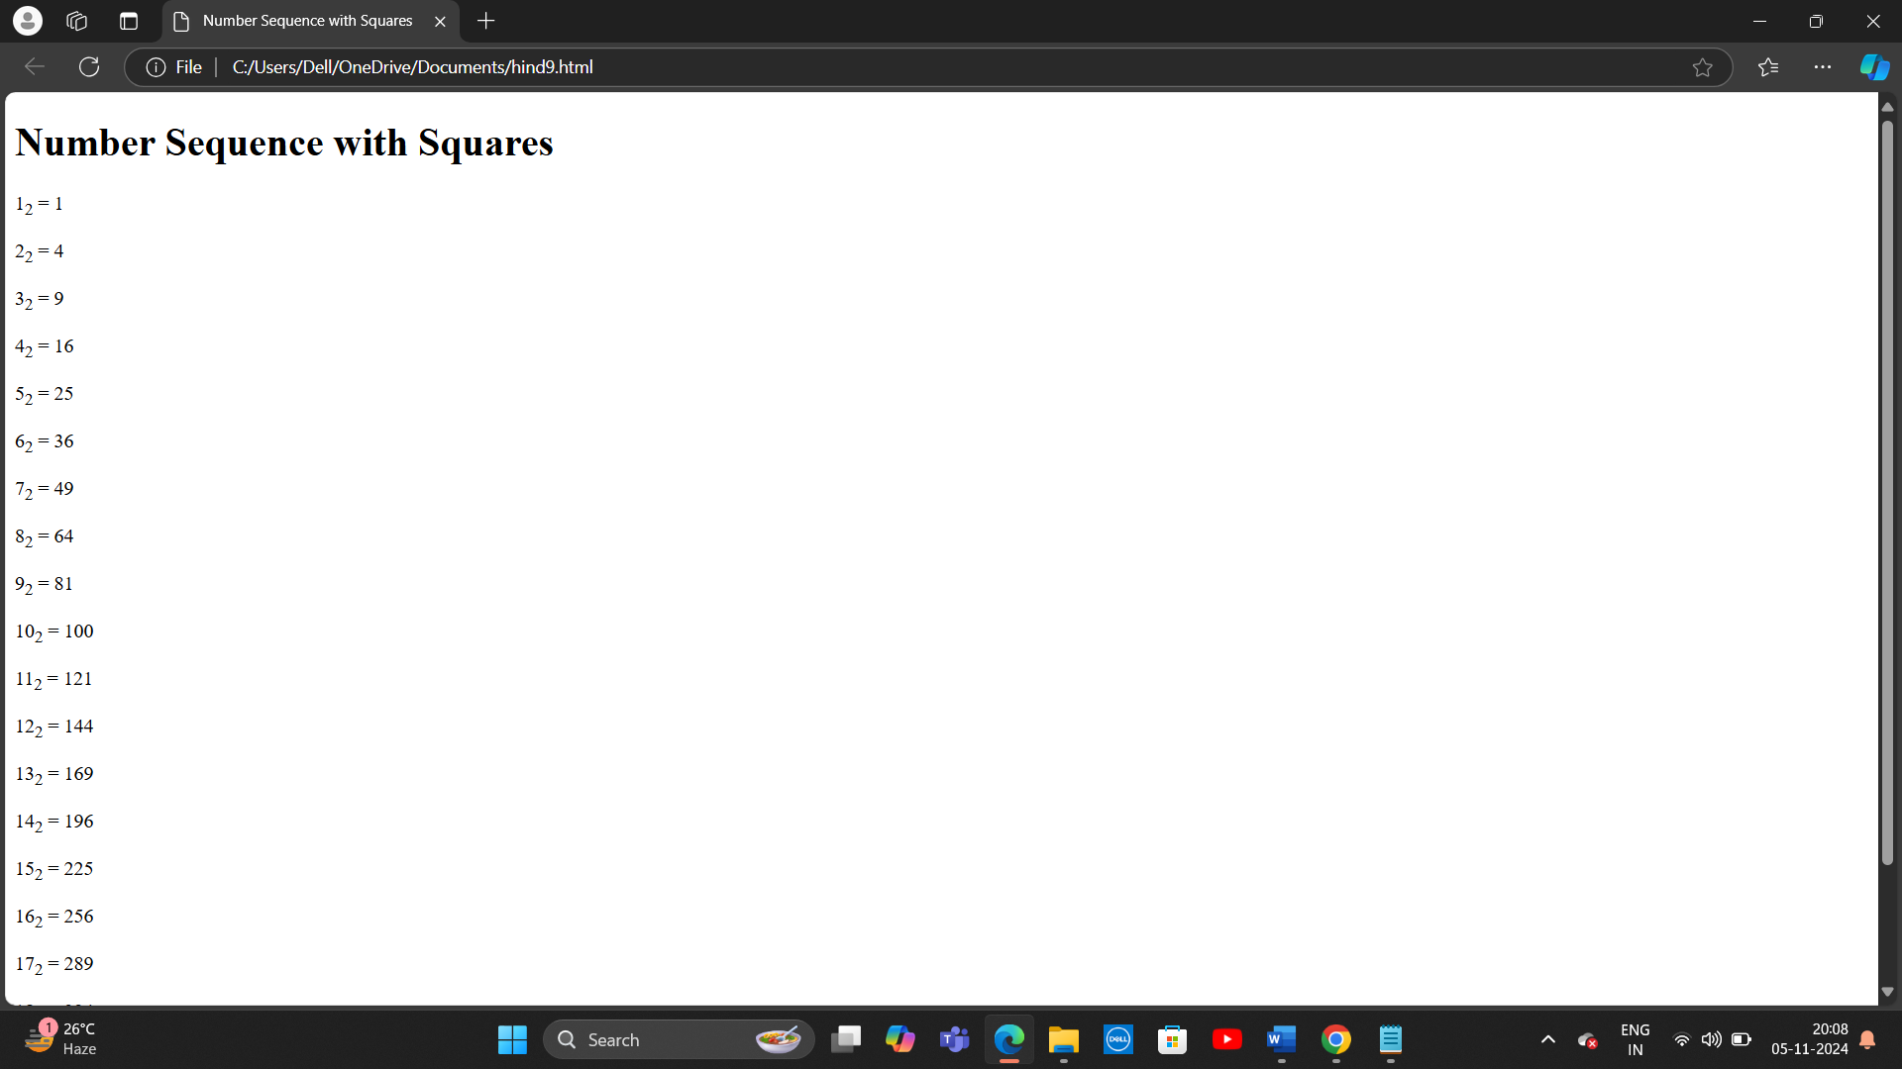

10. Write HTML code to display an image with border of size with width 200, height 200 pixels, leaving Hspace and Vspace of your choice with image hanging in the right side on the screen.

<!DOCTYPE html>

<html lang="en">

<head>

<meta charset="UTF-8">

<meta name="viewport" content="width=device-width, initial-scale=1.0">

<title>Image with Border and Spacing</title>

<style>

/* Style to position the image on the right */

.image-right {

float: right; /* Float the image to the right */

margin-right: 20px; /* Space on the right side */

margin-top: 20px; /* Space on the top side */

border: 5px solid black; /* Border with 5px width */

width: 200px; /* Set the width to 200px */

height: 200px; /* Set the height to 200px */

}

</style>

</head>

<body>

<h1>Image with Border and Spacing</h1>

<p>This is a sample image with a border, positioned on the right side of the page.</p>

<!-- Display the image with border and floating right -->

<img src="https://via.placeholder.com/200" alt="Sample Image" class="image-right">

<p>Here is some more content. The image is hanging on the right side, leaving space around it.</p>

</body>

</html>

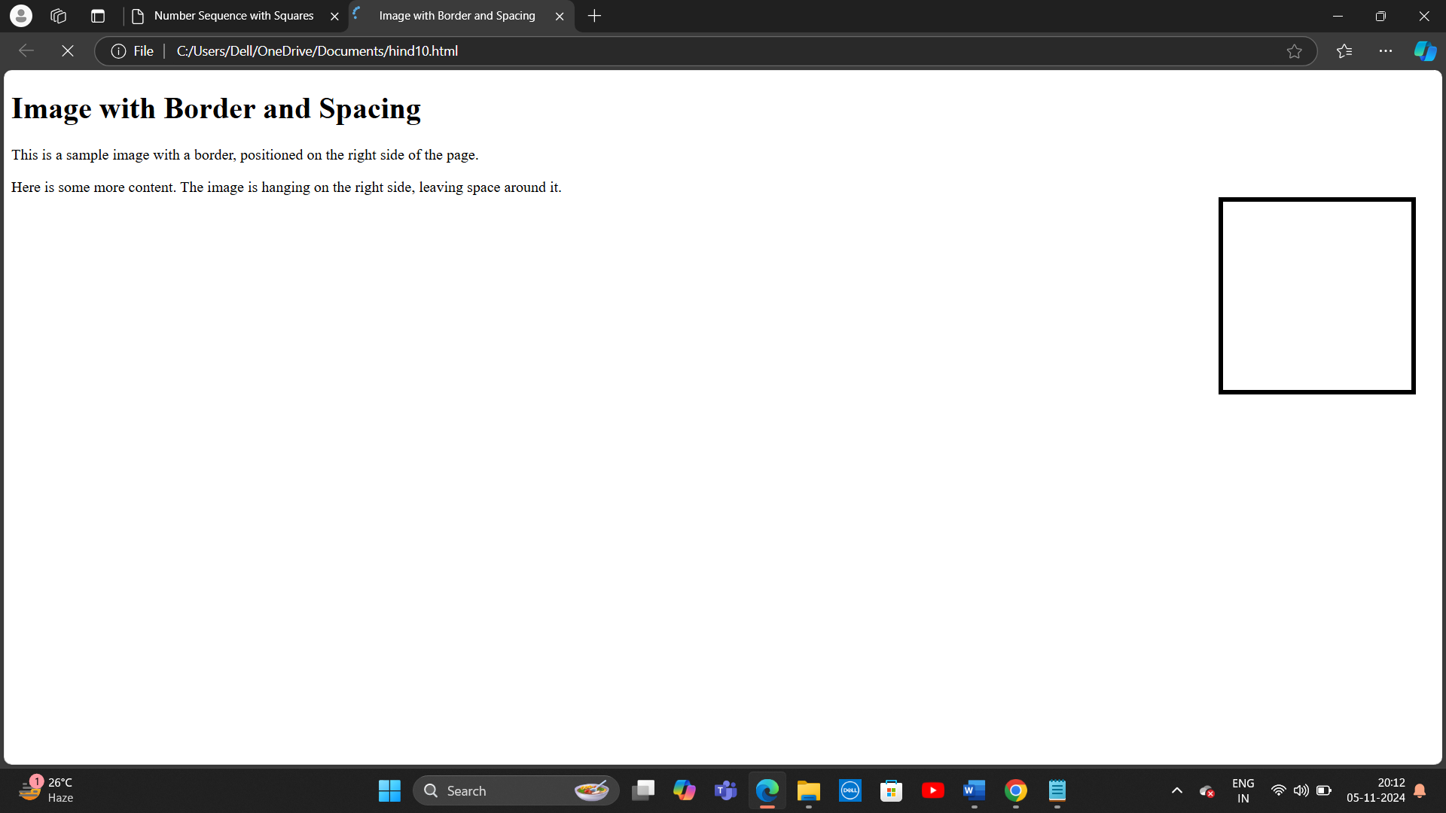

11 . Write HTML code to create a web page with heading. The heading shall be displayed at the top-center of the page and the image shall be at the centre, just below the heading.

<!DOCTYPE html>

<html lang="en">

<head>

<meta charset="UTF-8">

<meta name="viewport" content="width=device-width, initial-scale=1.0">

<title>Centered Heading and Image</title>

<style>

/* Center the heading */

h1 {

text-align: center; /* Center the heading horizontally */

margin-top: 50px; /* Add some space from the top of the page */

}

/* Center the image */

.center-image {

display: block; /* Make the image behave like a block element */

margin-left: auto; /* Center horizontally */

margin-right: auto; /* Center horizontally */

margin-top: 20px; /* Space between the heading and the image */

}

</style>

</head>

<body>

<!-- Centered heading -->

<h1>Welcome to My Web Page!</h1>

<!-- Centered image -->

<img src="https://via.placeholder.com/300" alt="Sample Image" class="center-image">

</body>

</html>

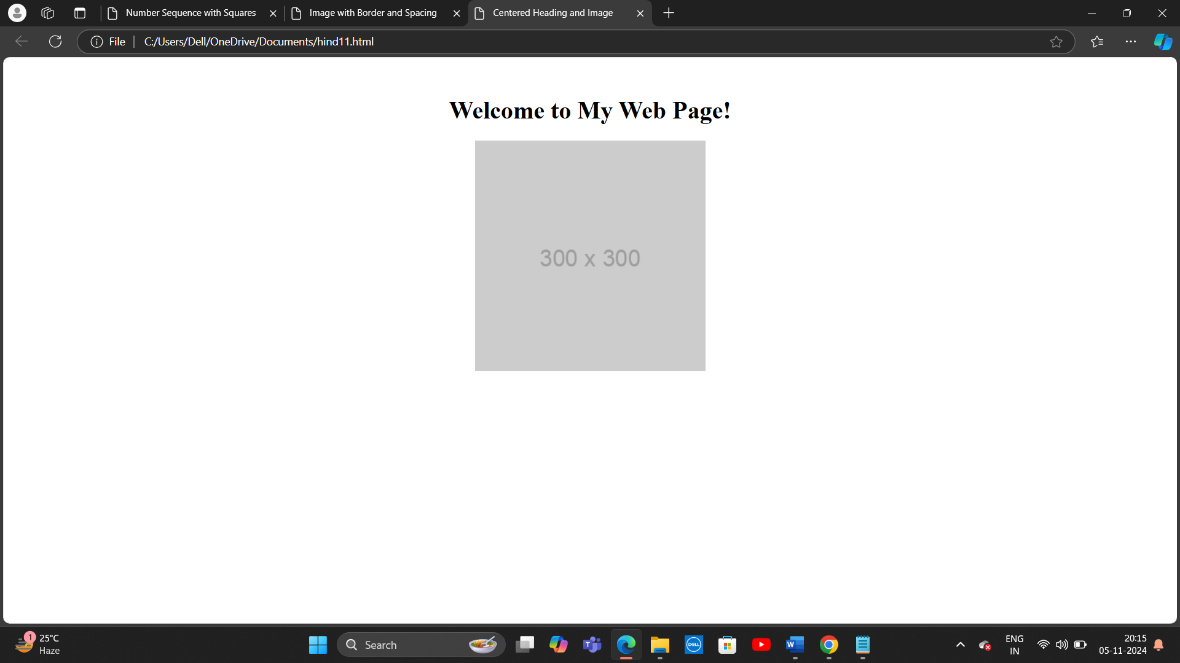

12, Write HTML code using Multimedia tags.

<!DOCTYPE html>

<html lang="en">

<head>

<meta charset="UTF-8">

<meta name="viewport" content="width=device-width, initial-scale=1.0">

<title>Multimedia Example</title>

</head>

<body>

<h1>Welcome to the Multimedia Page</h1>

<!-- Image Element -->

<h2>Image Example</h2>

<img src="https://via.placeholder.com/400" alt="Sample Image" width="400" height="300">

<p>This is an example of an image on the webpage.</p>

<!-- Audio Element -->

<h2>Audio Example</h2>

<audio controls>

<source src="https://www.soundhelix.com/examples/mp3/SoundHelix-Song-1.mp3" type="audio/mp3">

Your browser does not support the audio element.

</audio>

<p>This is an example of an audio file that can be played on the webpage.</p>

<!-- Video Element -->

<h2>Video Example</h2>

<video width="600" controls>

<source src="https://www.w3schools.com/html/movie.mp4" type="video/mp4">

Your browser does not support the video tag.

</video>

<p>This is an example of a video file that can be played on the webpage.</p>

</body>

</html>

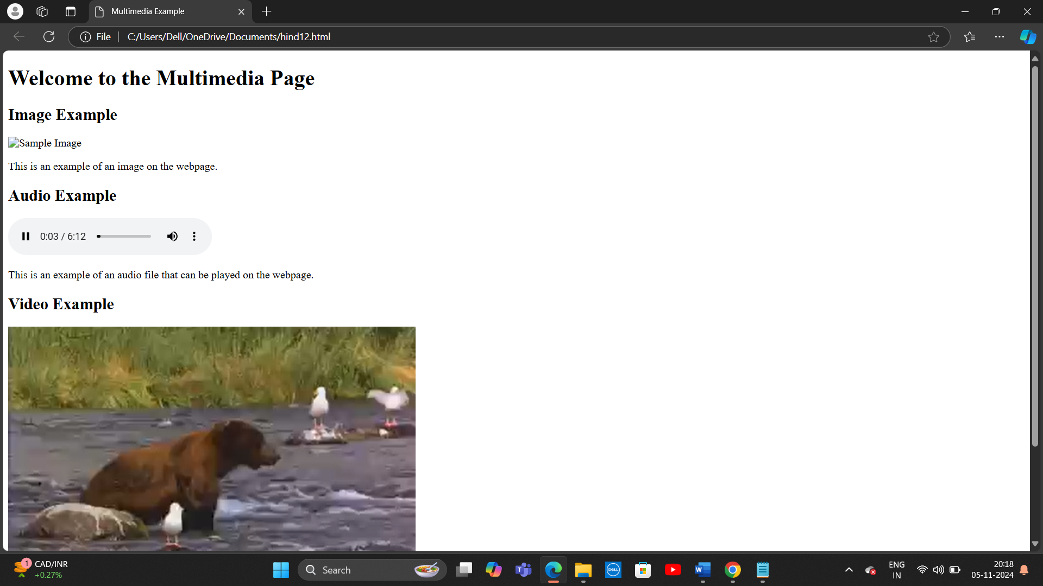

13. Create a Table using Rowspan and Colspan taking example of student Record.

<!DOCTYPE html>

<html lang="en">

<head>

<meta charset="UTF-8">

<meta name="viewport" content="width=device-width, initial-scale=1.0">

<title>Student Record Table</title>

<style>

table {

width: 100%;

border-collapse: collapse;

}

table, th, td {

border: 1px solid black;

}

th, td {

padding: 8px;

text-align: center;

}

</style>

</head>

<body>

<h1>Student Record Table</h1>

<!-- Student Record Table -->

<table>

<tr>

<th rowspan="2">Student ID</th>

<th colspan="2">Personal Information</th>

<th rowspan="2">Grade</th>

<th rowspan="2">Status</th>

</tr>

<tr>

<th>Name</th>

<th>Age</th>

</tr>

<!-- Student Record Row 1 -->

<tr>

<td>101</td>

<td>John Doe</td>

<td>20</td>

<td>A</td>

<td>Active</td>

</tr>

<!-- Student Record Row 2 -->

<tr>

<td>102</td>

<td>Jane Smith</td>

<td>22</td>

<td>B+</td>

<td>Inactive</td>

</tr>

<!-- Student Record Row 3 -->

<tr>

<td>103</td>

<td>Mark Taylor</td>

<td>19</td>

<td>A-</td>

<td>Active</td>

</tr>

</table>

</body>

</html>

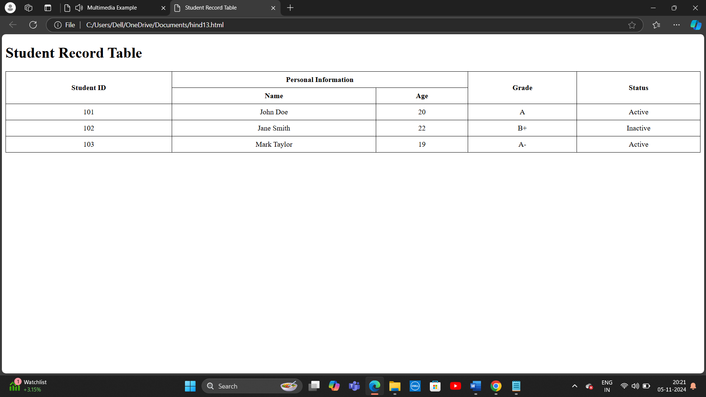

14. Write HTML code using table tag <table> and cellpadding and cell spacing as its attributes.

<!DOCTYPE html>

<html lang="en">

<head>

<meta charset="UTF-8">

<meta name="viewport" content="width=device-width, initial-scale=1.0">

<title>Table with Cellpadding and Cellspacing</title>

<style>

table {

width: 80%; /* Table width is 80% of the page */

border: 1px solid black;

}

th, td {

border: 1px solid #ccc; /* Add a light border around each cell */

text-align: center;

}

</style>

</head>

<body>

<h1>Table with Cellpadding and Cellspacing</h1>

<!-- Table with cellpadding and cellspacing -->

<table cellpadding="10" cellspacing="5">

<tr>

<th>Student ID</th>

<th>Student Name</th>

<th>Grade</th>

</tr>

<tr>

<td>101</td>

<td>John Doe</td>

<td>A</td>

</tr>

<tr>

<td>102</td>

<td>Jane Smith</td>

<td>B+</td>

</tr>

<tr>

<td>103</td>

<td>Mark Taylor</td>

<td>A-</td>

</tr>

</table>

</body>

</html>

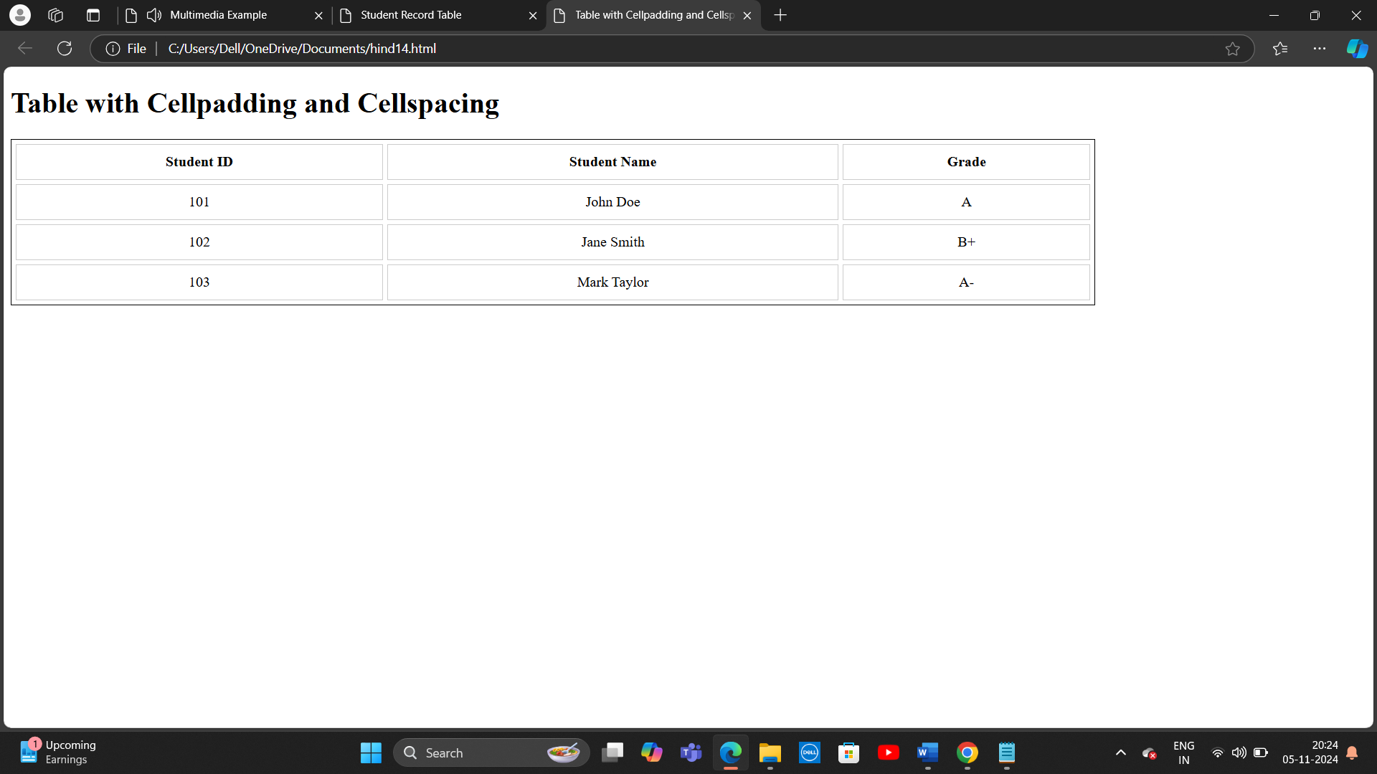

15. Create unordered, ordered and definition Lists taking example of your subjects in MCA IST, IInd and IIIrd Semester.

<!DOCTYPE html>

<html lang="en">

<head>

<meta charset="UTF-8">

<meta name="viewport" content="width=device-width, initial-scale=1.0">

<title>Lists in MCA Semesters</title>

</head>

<body>

<h1>Subjects in MCA Semesters</h1>

<!-- Unordered List (bulleted list) for MCA 1st Semester -->

<h2>MCA 1st Semester (Unordered List)</h2>

<ul>

<li>Mathematics I</li>

<li>Computer Programming</li>

<li>Digital Logic Design</li>

<li>Computer Networks</li>

<li>Database Management Systems</li>

</ul>

<!-- Ordered List (numbered list) for MCA 2nd Semester -->

<h2>MCA 2nd Semester (Ordered List)</h2>

<ol>

<li>Mathematics II</li>

<li>Operating Systems</li>

<li>Data Structures</li>

<li>Software Engineering</li>

<li>Web Technologies</li>

</ol>

<!-- Definition List for MCA 3rd Semester -->

<h2>MCA 3rd Semester (Definition List)</h2>

<dl>

<dt>Mathematics III</dt>

<dd>Advanced topics in mathematics, focusing on discrete mathematics and calculus.</dd>

<dt>Object-Oriented Programming</dt>

<dd>Study of object-oriented design and programming concepts using languages like Java and C++.</dd>

<dt>Computer Graphics</dt>

<dd>Introduction to the principles of computer graphics, including rendering, transformations, and 3D modeling.</dd>

<dt>Artificial Intelligence</dt>

<dd>Study of intelligent agents, search algorithms, machine learning, and problem-solving techniques.</dd>

<dt>Mobile Application Development</dt>

<dd>Learning mobile app development techniques for platforms like Android and iOS.</dd>

</dl>

</body>

</html>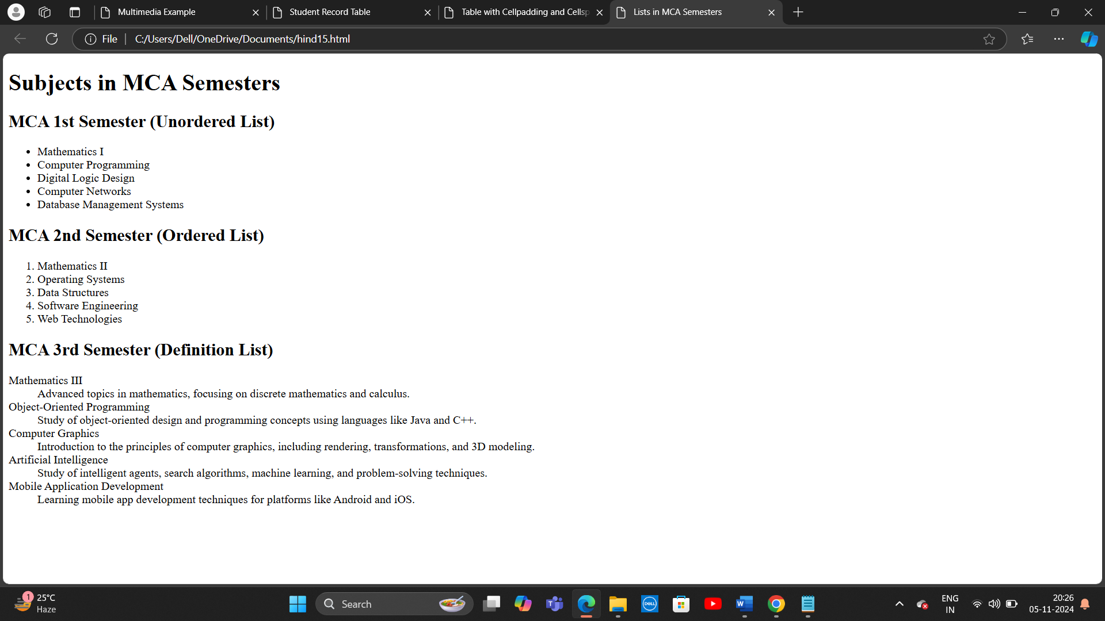

16. Write HTML code using <frameset> and <frame> tag with all its attributes

<!DOCTYPE html>

<html lang="en">

<head>

<meta charset="UTF-8">

<meta name="viewport" content="width=device-width, initial-scale=1.0">

<title>Frameset Example</title>

</head>

<body>

<!-- Using <frameset> to create a page layout with multiple frames -->

<frameset rows="50%, 50%" cols="50%, 50%">

<!-- Row 1: A two-column layout -->

<frame src="https://www.example.com" name="frame1" noresize scrolling="yes" target="_blank">

<!-- Row 2: A two-column layout -->

<frame src="https://www.w3schools.com" name="frame2" noresize scrolling="auto">

</frameset>

</body>

</html>

17. Write HTML code to design a form in HTML using controls and buttons such as Textbox, Text area, password, submit button, browse button, drop-down menu

<!DOCTYPE html>

<html lang="en">

<head>

<meta charset="UTF-8">

<meta name="viewport" content="width=device-width, initial-scale=1.0">

<title>HTML Form Example</title>

<style>

body {

font-family: Arial, sans-serif;

margin: 50px;

}

form {

max-width: 600px;

margin: 0 auto;

padding: 20px;

border: 1px solid #ccc;

border-radius: 10px;

background-color: #f9f9f9;

}

label {

font-weight: bold;

display: block;

margin: 10px 0 5px;

}

input, textarea, select {

width: 100%;

padding: 10px;

margin: 5px 0 15px;

border: 1px solid #ccc;

border-radius: 5px;

}

input[type="submit"] {

width: auto;

background-color: #4CAF50;

color: white;

border: none;

cursor: pointer;

padding: 10px 20px;

font-size: 16px;

}

input[type="submit"]:hover {

background-color: #45a049;

}

</style>

</head>

<body>

<h1>Registration Form</h1>

<form action="submit_form.php" method="POST">

<!-- Textbox for Full Name -->

<label for="fullname">Full Name:</label>

<input type="text" id="fullname" name="fullname" required>

<!-- Textarea for Address -->

<label for="address">Address:</label>

<textarea id="address" name="address" rows="4" required></textarea>

<!-- Password Field -->

<label for="password">Password:</label>

<input type="password" id="password" name="password" required>

<!-- Browse Button for File Upload -->

<label for="fileupload">Upload File:</label>

<input type="file" id="fileupload" name="fileupload">

<!-- Drop-down Menu for Selecting Gender -->

<label for="gender">Gender:</label>

<select id="gender" name="gender" required>

<option value="">Select Gender</option>

<option value="male">Male</option>

<option value="female">Female</option>

<option value="other">Other</option>

</select>

<!-- Submit Button -->

<input type="submit" value="Submit">

</form>

</body>

</html>

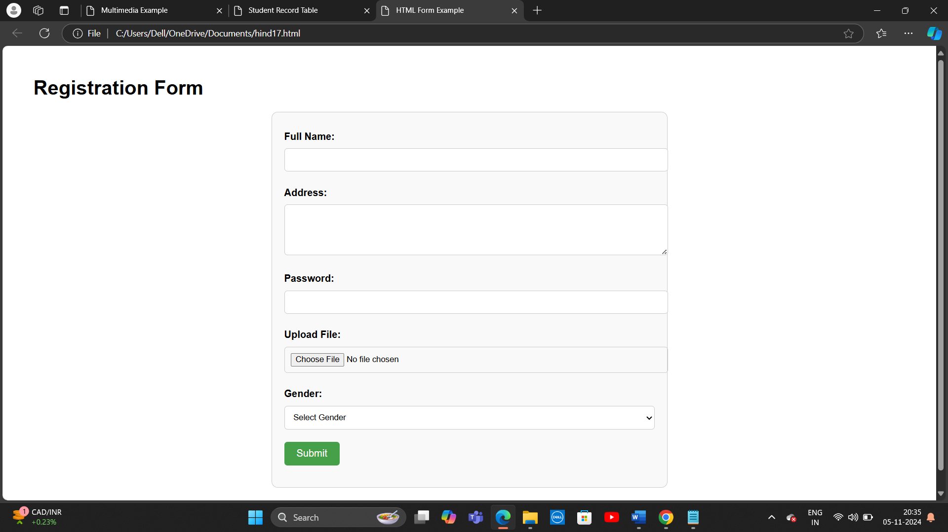

18. Write HTML code to design a Registration Form in HTML.

<!DOCTYPE html>

<html lang="en">

<head>

<meta charset="UTF-8">

<meta name="viewport" content="width=device-width, initial-scale=1.0">

<title>Registration Form</title>

<style>

body {

font-family: Arial, sans-serif;

margin: 50px;

background-color: #f4f4f9;

}

form {

max-width: 600px;

margin: 0 auto;

padding: 30px;

border: 1px solid #ccc;

border-radius: 10px;

background-color: white;

}

h1 {

text-align: center;

color: #4CAF50;

}

label {

font-weight: bold;

margin-top: 10px;

display: block;

}

input, select, textarea {

width: 100%;

padding: 10px;

margin: 8px 0 15px 0;

border: 1px solid #ccc;

border-radius: 5px;

font-size: 16px;

}

input[type="submit"] {

width: auto;

background-color: #4CAF50;

color: white;

border: none;

cursor: pointer;

padding: 10px 20px;

font-size: 16px;

}

input[type="submit"]:hover {

background-color: #45a049;

}

.form-group {

margin-bottom: 15px;

}

</style>

</head>

<body>

<h1>Registration Form</h1>

<form action="submit_registration.php" method="POST">

<!-- Full Name -->

<div class="form-group">

<label for="fullname">Full Name:</label>

<input type="text" id="fullname" name="fullname" required placeholder="Enter your full name">

</div>

<!-- Email Address -->

<div class="form-group">

<label for="email">Email:</label>

<input type="email" id="email" name="email" required placeholder="Enter your email">

</div>

<!-- Password -->

<div class="form-group">

<label for="password">Password:</label>

<input type="password" id="password" name="password" required placeholder="Enter your password" minlength="8">

</div>

<!-- Confirm Password -->

<div class="form-group">

<label for="confirmpassword">Confirm Password:</label>

<input type="password" id="confirmpassword" name="confirmpassword" required placeholder="Confirm your password" minlength="8">

</div>

<!-- Gender -->

<div class="form-group">

<label for="gender">Gender:</label>

<select id="gender" name="gender" required>

<option value="">Select Gender</option>

<option value="male">Male</option>

<option value="female">Female</option>

<option value="other">Other</option>

</select>

</div>

<!-- Date of Birth -->

<div class="form-group">

<label for="dob">Date of Birth:</label>

<input type="date" id="dob" name="dob" required>

</div>

<!-- Phone Number -->

<div class="form-group">

<label for="phone">Phone Number:</label>

<input type="tel" id="phone" name="phone" required placeholder="Enter your phone number" pattern="[0-9]{10}">

</div>

<!-- Address -->

<div class="form-group">

<label for="address">Address:</label>

<textarea id="address" name="address" rows="4" required placeholder="Enter your address"></textarea>

</div>

<!-- Submit Button -->

<div class="form-group">

<input type="submit" value="Register">

</div>

</form>

</body>

</html>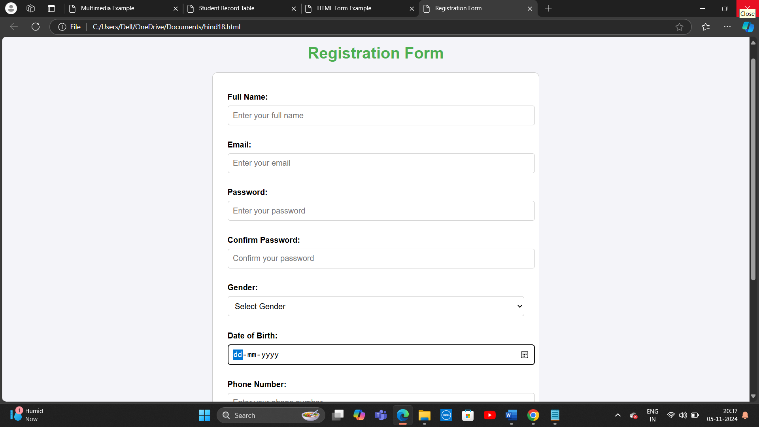

19. Write HTML code to design a student admission Form in HTML.

<!DOCTYPE html>

<html lang="en">

<head>

<meta charset="UTF-8">

<meta name="viewport" content="width=device-width, initial-scale=1.0">

<title>Student Admission Form</title>

<style>

body {

font-family: Arial, sans-serif;

margin: 50px;

background-color: #f9f9f9;

}

form {

max-width: 800px;

margin: 0 auto;

padding: 30px;

border: 1px solid #ccc;

border-radius: 10px;

background-color: white;

}

h1 {

text-align: center;

color: #4CAF50;

}

label {

font-weight: bold;

margin-top: 10px;

display: block;

}

input, select, textarea {

width: 100%;

paddin

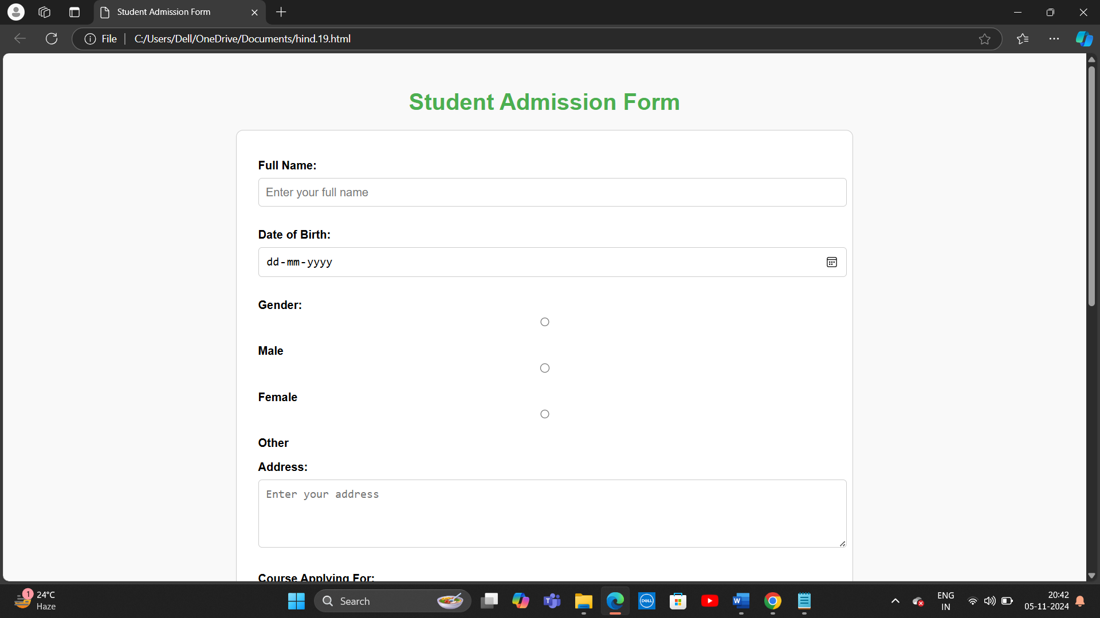

20 . Create a proper home page of your own using any components and styles.

<!DOCTYPE html>

<html lang="en">

<head>

<meta charset="UTF-8">

<meta name="viewport" content="width=device-width, initial-scale=1.0">

<title>My Personal Home Page</title>

<style>

body {

font-family: Arial, sans-serif;

background-color: #f4f4f9;

margin: 0;

padding: 0;

}

header {

background-color: #4CAF50;

color: white;

text-align: center;

padding: 20px;

}

header h1 {

margin: 0;

}

nav {

background-color: #333;

overflow: hidden;

}

nav a {

float: left;

display: block;

color: white;

text-align: center;

padding: 14px 20px;

text-decoration: none;

}

nav a:hover {

background-color: #ddd;

color: black;

}

.main-content {

display: flex;

justify-content: space-between;

padding: 20px;

margin-top: 20px;

}

.main-content .left, .main-content .right {

width: 48%;

}

.left {

background-color: #ffffff;

padding: 15px;

box-shadow: 0 0 10px rgba(0, 0, 0, 0.1);

}

.right {

background-color: #ffffff;

padding: 15px;

box-shadow: 0 0 10px rgba(0, 0, 0, 0.1);

}

.about, .contact {

background-color: #ffffff;

padding: 15px;

margin-bottom: 20px;

box-shadow: 0 0 10px rgba(0, 0, 0, 0.1);

}

footer {

background-color: #333;

color: white;

text-align: center;

padding: 10px 0;

position: fixed;

width: 100%;

bottom: 0;

}

footer p {

margin: 0;

}

.image {

width: 100%;

height: auto;

border-radius: 5px;

}

.card {

background-color: #ffffff;

padding: 20px;

margin-bottom: 20px;

box-shadow: 0 0 10px rgba(0, 0, 0, 0.1);

border-radius: 5px;

}

.card img {

width: 100%;

height: auto;

border-radius: 5px;

}

.card h3 {

margin-top: 10px;

}

.card p {

margin: 10px 0;

}

</style>

</head>

<body>

<!-- Header Section -->

<header>

<h1>Welcome to My Personal Home Page</h1>

<p>Your gateway to learn more about me, my projects, and my interests!</p>

</header>

<!-- Navigation Bar -->

<nav>

<a href="#about">About Me</a>

<a href="#projects">Projects</a>

<a href="#contact">Contact</a>

</nav>

<!-- Main Content Section -->

<div class="main-content">

<!-- Left Section (About Me) -->

<div class="left" id="about">

<div class="about">

<h2>About Me</h2>

<img src="https://via.placeholder.com/350" alt="Profile Picture" class="image">

<p>Hi, I'm John Doe, a passionate web developer with a love for creating dynamic and interactive websites. I'm currently learning new technologies and working on projects to enhance my skills. I enjoy solving problems and building efficient systems. Let's connect!</p>

</div>

</div>

<!-- Right Section (Projects) -->

<div class="right" id="projects">

<div class="card">

<h3>Project 1: Personal Blog</h3>

<img src="https://via.placeholder.com/600x300" alt="Blog Project">

<p>A simple and clean personal blog website that allows users to write and share articles. Built using HTML, CSS, and JavaScript.</p>

</div>

<div class="card">

<h3>Project 2: To-Do List App</h3>

<img src="https://via.placeholder.com/600x300" alt="To-Do List Project">

<p>An efficient to-do list app built using ReactJS that helps users manage their daily tasks and stay organized.</p>

</div>

<div class="card">

<h3>Project 3: Portfolio Website</h3>

<img src="https://via.placeholder.com/600x300" alt="Portfolio Project">

<p>A personal portfolio website showcasing my skills, projects, and achievements. Built using HTML, CSS, and JavaScript.</p>

</div>

</div>

</div>

<!-- Contact Section -->

<div id="contact">

<div class="contact">

<h2>Contact Me</h2>

<p>If you'd like to get in touch, feel free to drop me a message below:</p>

<form action="#" method="POST">

<label for="name">Name:</label>

<input type="text" id="name" name="name" required placeholder="Your Name">

<label for="email">Email:</label>

<input type="email" id="email" name="email" required placeholder="Your Email">

<label for="message">Message:</label>

<textarea id="message" name="message" rows="4" required placeholder="Your Message"></textarea>

<input type="submit" value="Send Message">

</form>

</div>

</div>

<!-- Footer Section -->

<footer>

<p>&copy; 2024 John Doe. All rights reserved.</p>

</footer>

</body>

</html>

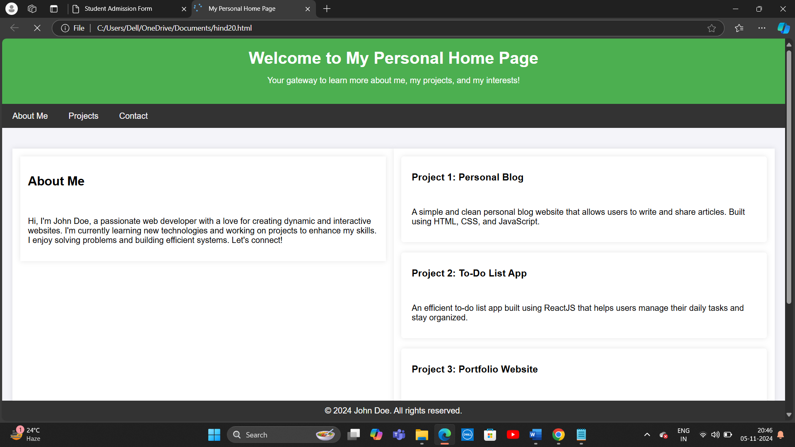

20. Write HTML code for including Local hyperlinking in a web page.

<!DOCTYPE html>

<html lang="en">

<head>

<meta charset="UTF-8">

<meta name="viewport" content="width=device-width, initial-scale=1.0">

<title>Local Hyperlinking Example</title>

<style>

body {

font-family: Arial, sans-serif;

background-color: #f4f4f9;

margin: 0;

padding: 0;

}

header {

background-color: #4CAF50;

color: white;

padding: 15px;

text-align: center;

}

nav {

background-color: #333;

padding: 10px;

}

nav a {

color: white;

text-decoration: none;

padding: 10px 20px;

display: inline-block;

}

nav a:hover {

background-color: #ddd;

color: black;

}

section {

padding: 20px;

margin: 20px 0;

background-color: white;

box-shadow: 0 0 10px rgba(0, 0, 0, 0.1);

}

section h2 {

color: #4CAF50;

}

</style>

</head>

<body>

<!-- Header -->

<header>

<h1>Welcome to My Local Hyperlinking Page</h1>

<p>Click on the links below to navigate to different sections of the page.</p>

</header>

<!-- Navigation -->

<nav>

<a href="#section1">Section 1</a>

<a href="#section2">Section 2</a>

<a href="#section3">Section 3</a>

</nav>

<!-- Sections -->

<section id="section1">

<h2>Section 1: Introduction</h2>

<p>This is the first section of the page. Click on the navigation links above to jump to other sections.</p>

</section>

<section id="section2">

<h2>Section 2: Details</h2>

<p>This is the second section of the page. It can be accessed by clicking on the "Section 2" link in the navigation bar.</p>

</section>

<section id="section3">

<h2>Section 3: Conclusion</h2>

<p>This is the third section of the page. You can return to any of the previous sections by using the navigation links above.</p>

</section>

</body>

</html>

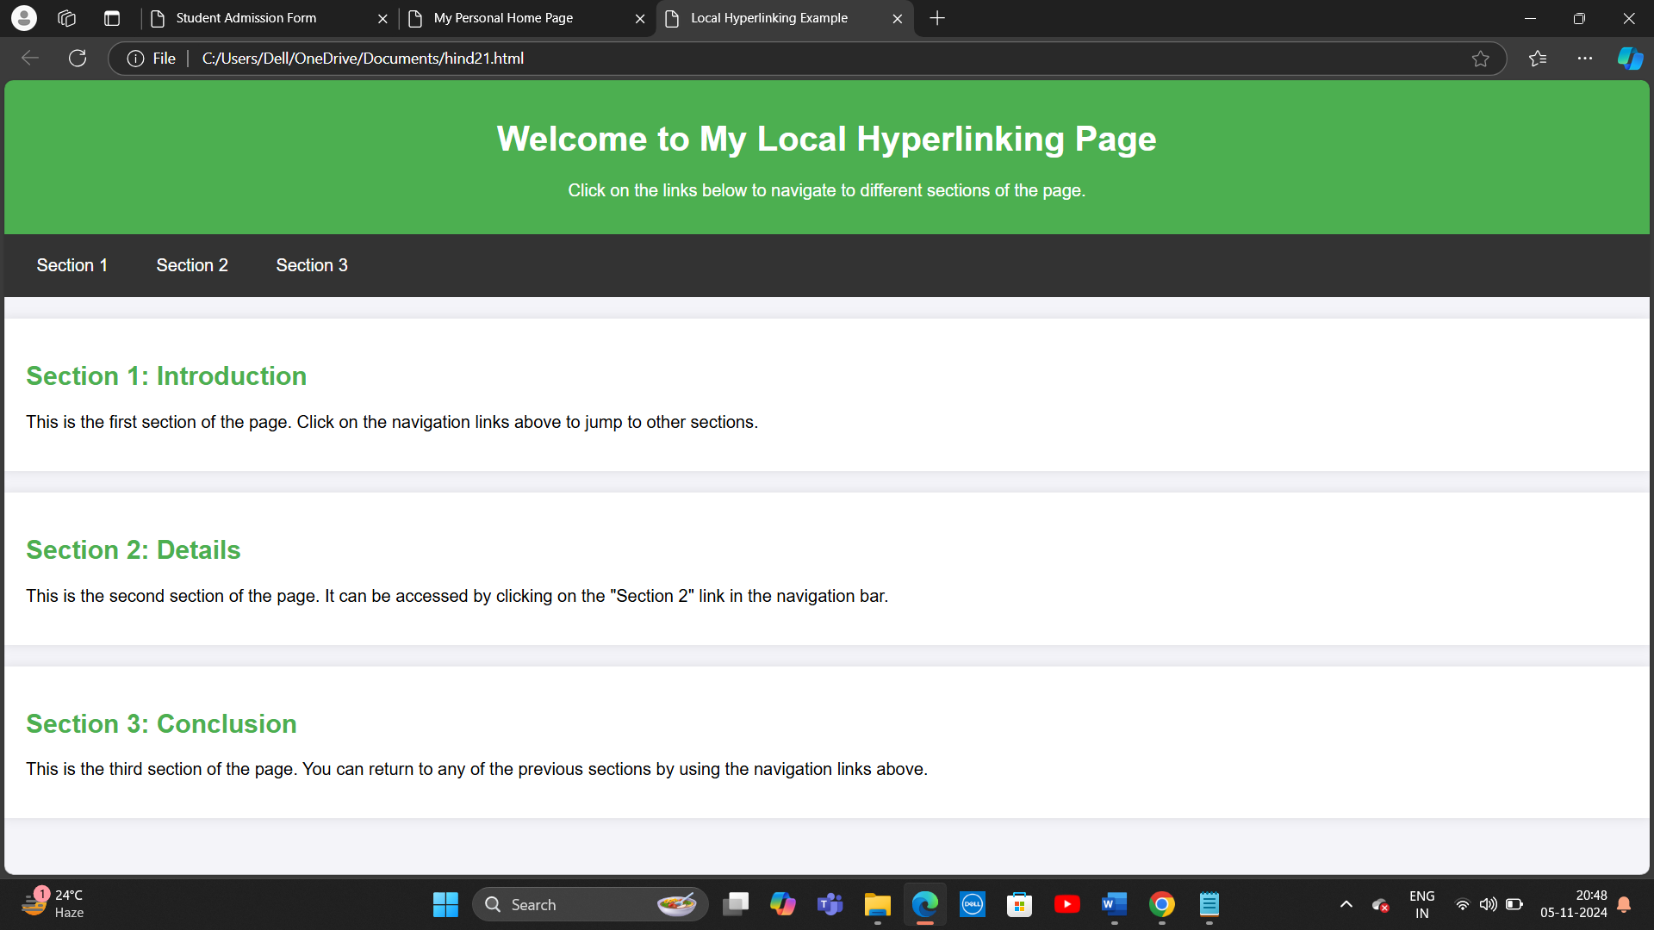

22. Write HTML code for including Inter hyperlinking in a web page.

<!DOCTYPE html>

<html lang="en">

<head>

<meta charset="UTF-8">

<meta name="viewport" content="width=device-width, initial-scale=1.0">

<title>Inter Hyperlinking Example</title>

<style>

body {

font-family: Arial, sans-serif;

background-color: #f4f4f9;

margin: 0;

padding: 0;

}

header {

background-color: #4CAF50;

color: white;

padding: 20px;

text-align: center;

}

nav {

background-color: #333;

padding: 10px;

}

nav a {

color: white;

text-decoration: none;

padding: 10px 20px;

display: inline-block;

}

nav a:hover {

background-color: #ddd;

color: black;

}

section {

padding: 20px;

margin: 20px 0;

background-color: white;

box-shadow: 0 0 10px rgba(0, 0, 0, 0.1);

}

section h2 {

color: #4CAF50;

}

.link-section {

background-color: #ffffff;

padding: 15px;

margin: 15px 0;

box-shadow: 0 0 10px rgba(0, 0, 0, 0.1);

}

</style>

</head>

<body>

<!-- Header Section -->

<header>

<h1>Inter Hyperlinking Example</h1>

<p>This page demonstrates how to create hyperlinks to external websites.</p>

</header>

<!-- Navigation Bar -->

<nav>

<a href="#about">About</a>

<a href="#links">Links</a>

<a href="https://www.example.com" target="_blank">Go to Example.com</a>

</nav>

<!-- Sections -->

<section id="about">

<h2>About Inter Hyperlinking</h2>

<p>Inter hyperlinking allows you to link to other pages or websites outside your current webpage. It is commonly used to connect related content or direct users to external resources.</p>

</section>

<section id="links" class="link-section">

<h2>Useful Links</h2>

<ul>

<li><a href="https://www.wikipedia.org" target="_blank">Visit Wikipedia</a></li>

<li><a href="https://www.github.com" target="_blank">Check out GitHub</a></li>

<li><a href="https://www.mozilla.org" target="_blank">Learn more about Mozilla</a></li>

</ul>

</section>

<!-- Footer Section -->

<footer>

<p>&copy; 2024 Inter Hyperlinking Demo</p>

</footer>

</body>

</html>

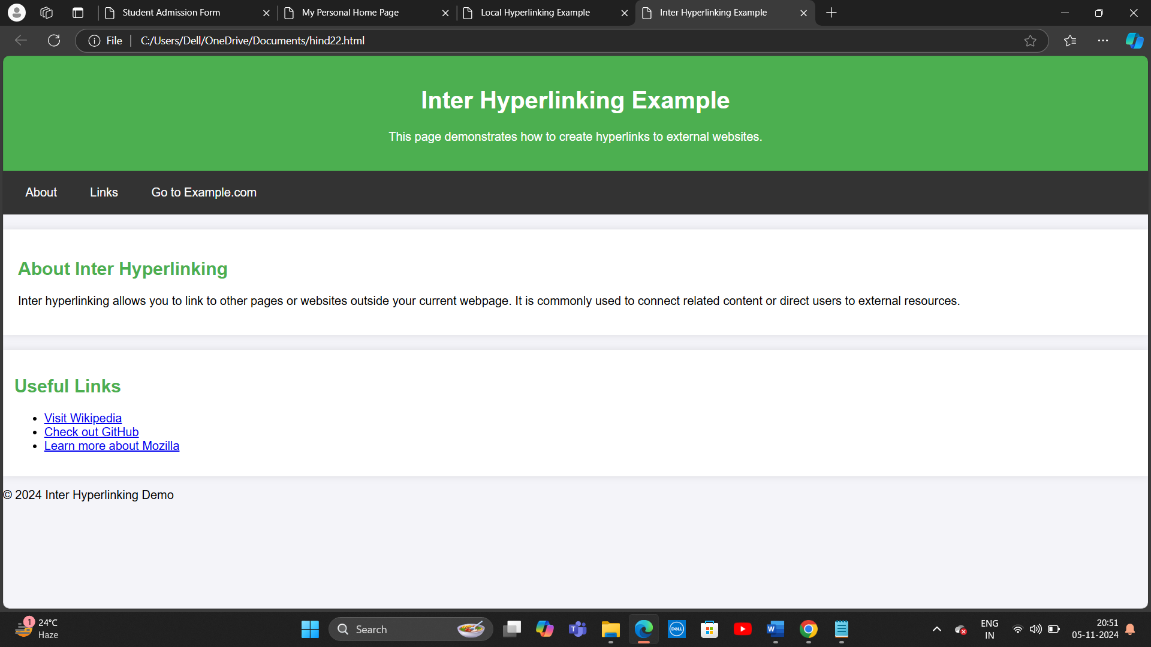

23. Write HTML code for including External hyperlinking in a web page.

<!DOCTYPE html>

<html lang="en">

<head>

<meta charset="UTF-8">

<meta name="viewport" content="width=device-width, initial-scale=1.0">

<title>External Hyperlinking Example</title>

<style>

body {

font-family: Arial, sans-serif;

background-color: #f4f4f9;

margin: 0;

padding: 0;

}

header {

background-color: #4CAF50;

color: white;

padding: 20px;

text-align: center;

}

nav {

background-color: #333;

padding: 10px;

}

nav a {

color: white;

text-decoration: none;

padding: 10px 20px;

display: inline-block;

}

nav a:hover {

background-color: #ddd;

color: black;

}

section {

padding: 20px;

margin: 20px 0;

background-color: white;

box-shadow: 0 0 10px rgba(0, 0, 0, 0.1);

}

section h2 {

color: #4CAF50;

}

.link-section {

background-color: #ffffff;

padding: 15px;

margin: 15px 0;

box-shadow: 0 0 10px rgba(0, 0, 0, 0.1);

}

</style>

</head>

<body>

<!-- Header Section -->

<header>

<h1>External Hyperlinking Example</h1>

<p>This page demonstrates how to create hyperlinks to external websites.</p>

</header>

<!-- Navigation Bar -->

<nav>

<a href="#about">About</a>

<a href="#links">Links</a>

</nav>

<!-- About Section -->

<section id="about">

<h2>About External Hyperlinking</h2>

<p>External hyperlinking refers to linking to websites that are not part of your own website. This is useful for providing additional information or directing users to related content hosted elsewhere on the internet.</p>

</section>

<!-- External Links Section -->

<section id="links" class="link-section">

<h2>Useful External Links</h2>

<ul>

<li><a href="https://www.wikipedia.org" target="_blank">Visit Wikipedia</a></li>

<li><a href="https://www.github.com" target="_blank">Check out GitHub</a></li>

<li><a href="https://www.mozilla.org" target="_blank">Learn more about Mozilla</a></li>

<li><a href="https://www.stackoverflow.com" target="_blank">Explore Stack Overflow</a></li>

<li><a href="https://www.reddit.com" target="_blank">Join Reddit</a></li>

</ul>

</section>

<!-- Footer Section -->

<footer>

<p>&copy; 2024 External Hyperlinking Demo</p>

</footer>

</body>

</html>

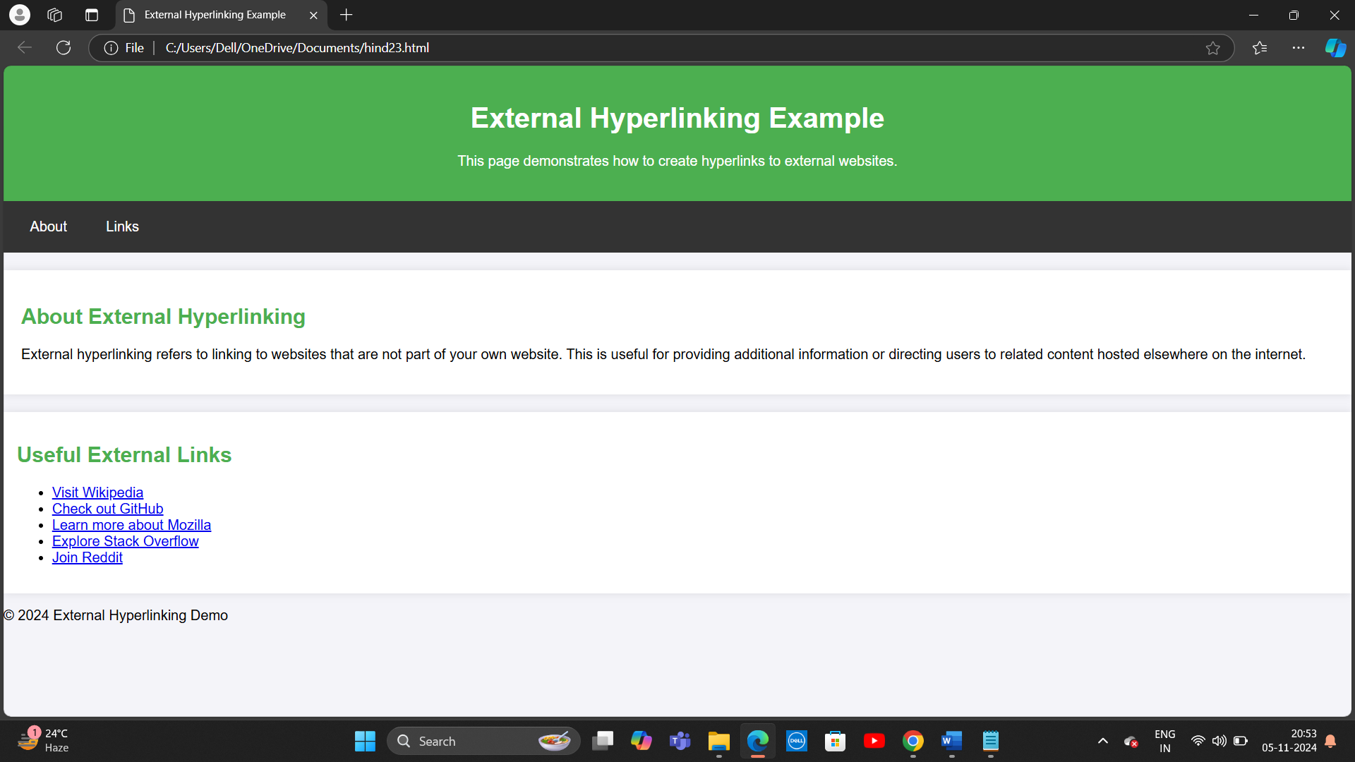

24. Write code to show External CSS with HTML code

/* styles.css */

/* Apply styles to the body */

body {

font-family: Arial, sans-serif;

background-color: #f4f4f9;

margin: 0;

padding: 0;

}

/* Style for the header section */

header {

background-color: #4CAF50;

color: white;

padding: 20px;

text-align: center;

}

/* Style for the navigation bar */

nav {

background-color: #333;

padding: 10px;

}

/* Style for the navigation links */

nav a {

color: white;

text-decoration: none;

padding: 10px 20px;

display: inline-block;

}

/* Change the color of the navigation links when hovered */

nav a:hover {

background-color: #ddd;

color: black;

}

/* Style for the section */

section {

padding: 20px;

margin: 20px 0;

background-color: white;

box-shadow: 0 0 10px rgba(0, 0, 0, 0.1);

}

/* Style for headings inside the section */

section h2 {

color: #4CAF50;

}

/* Style for the footer */

footer {

background-color: #333;

color: white;

text-align: center;

padding: 10px;

position: fixed;

width: 100%;

bottom: 0;

}

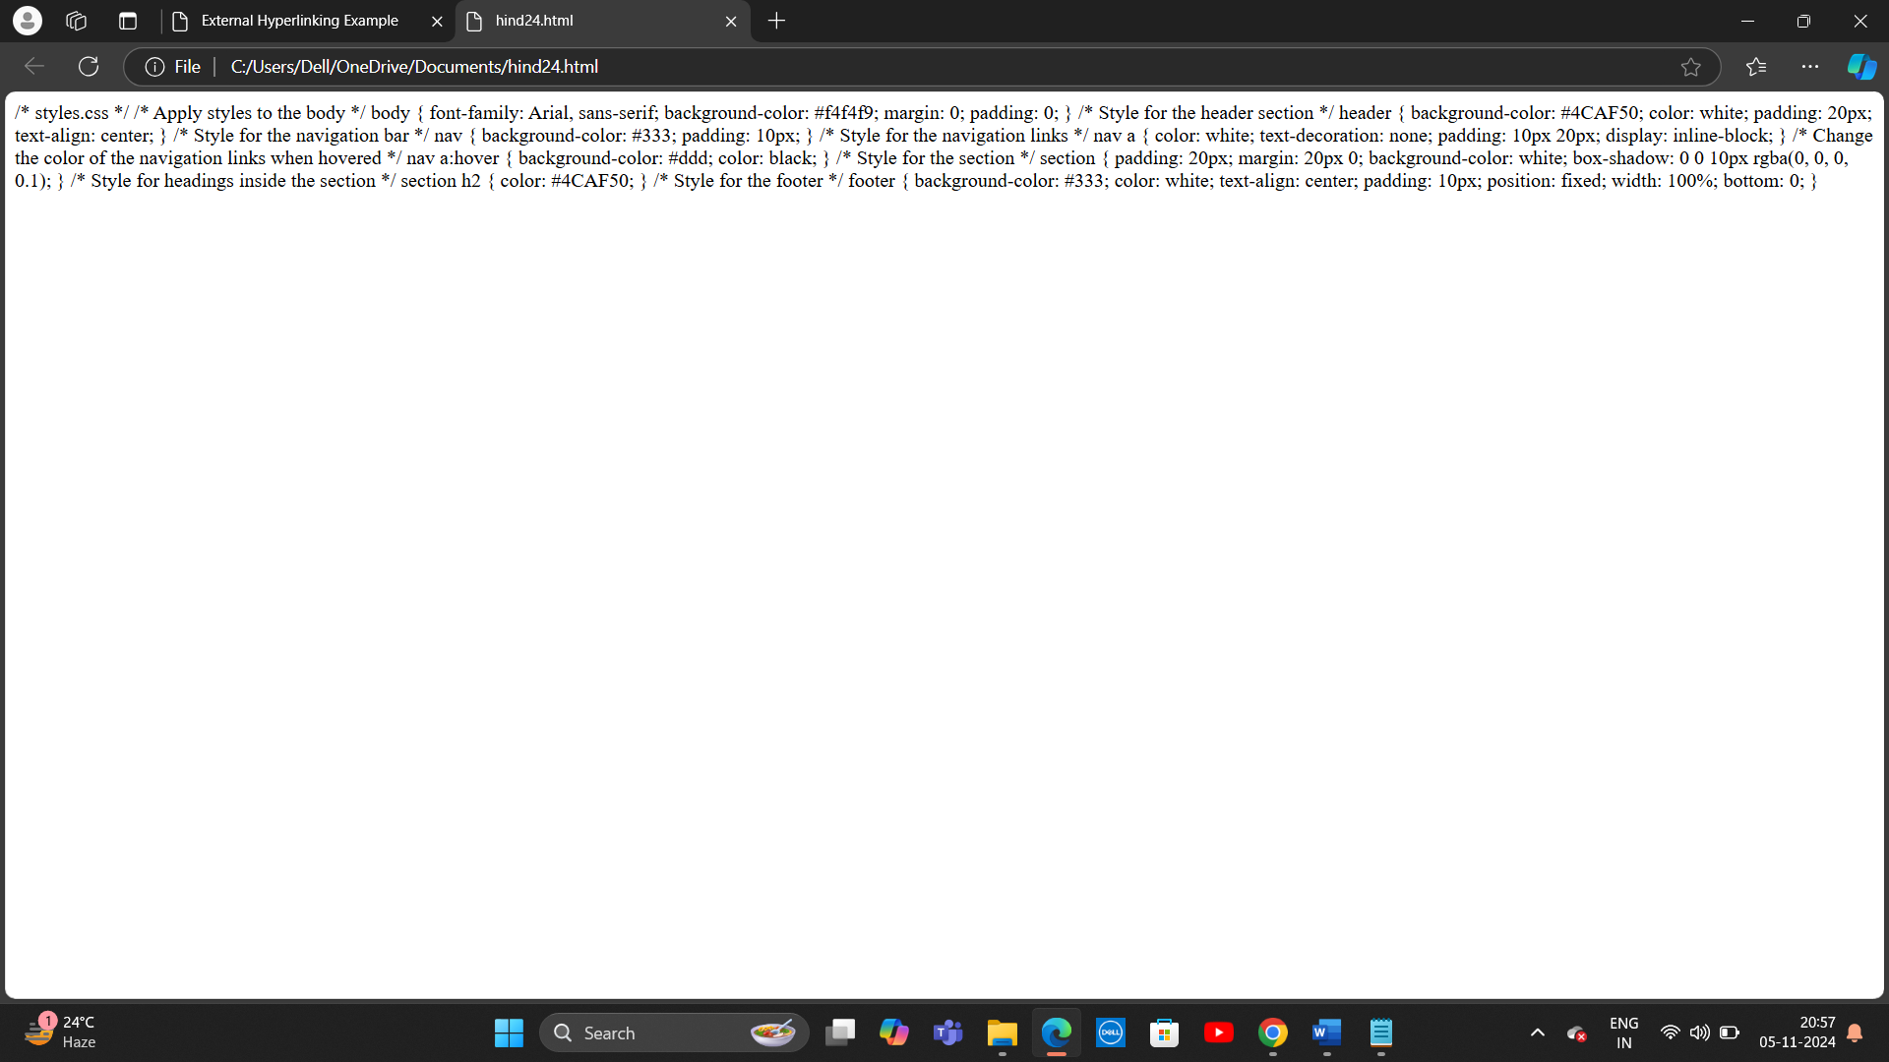

25. Write code to show Internal CSS with HTML code.

<!DOCTYPE html>

<html lang="en">

<head>

<meta charset="UTF-8">

<meta name="viewport" content="width=device-width, initial-scale=1.0">

<title>Internal CSS Example</title>

<!-- Internal CSS -->

<style>

/* General body styles */

body {

font-family: Arial, sans-serif;

background-color: #f4f4f9;

margin: 0;

padding: 0;

}

/* Header Section Styles */

header {

background-color: #4CAF50;

color: white;

padding: 20px;

text-align: center;

}

/* Navigation Bar Styles */

nav {

background-color: #333;

padding: 10px;

}

/* Style for navigation links */

nav a {

color: white;

text-decoration: none;

padding: 10px 20px;

display: inline-block;

}

/* Change color when hovering over navigation links */

nav a:hover {

background-color: #ddd;

color: black;

}

/* Section Styles */

section {

padding: 20px;

margin: 20px 0;

background-color: white;

box-shadow: 0 0 10px rgba(0, 0, 0, 0.1);

}

/* Section headings */

section h2 {

color: #4CAF50;

}

/* Footer Styles */

footer {

background-color: #333;

color: white;

text-align: center;

padding: 10px;

position: fixed;

width: 100%;

bottom: 0;

}

</style>

</head>

<body>

<!-- Header Section -->

<header>

<h1>Internal CSS Example</h1>

<p>This page demonstrates the use of internal CSS for styling.</p>

</header>

<!-- Navigation Bar -->

<nav>

<a href="#about">About</a>

<a href="#services">Services</a>

<a href="#contact">Contact</a>

</nav>

<!-- About Section -->

<section id="about">

<h2>About</h2>

<p>This section contains information about the website. The layout and styles are applied using internal CSS.</p>

</section>

<!-- Services Section -->

<section id="services">

<h2>Our Services</h2>

<p>We offer web development, mobile app development, and digital marketing services. Learn more about what we can do for you.</p>

</section>

<!-- Contact Section -->

<section id="contact">

<h2>Contact Us</h2>

<p>Get in touch with us through the contact form or via email for any inquiries or collaborations.</p>

</section>

<!-- Footer Section -->

<footer>

<p>&copy; 2024 Internal CSS Example. All rights reserved.</p>

</footer>

</body>

</html>

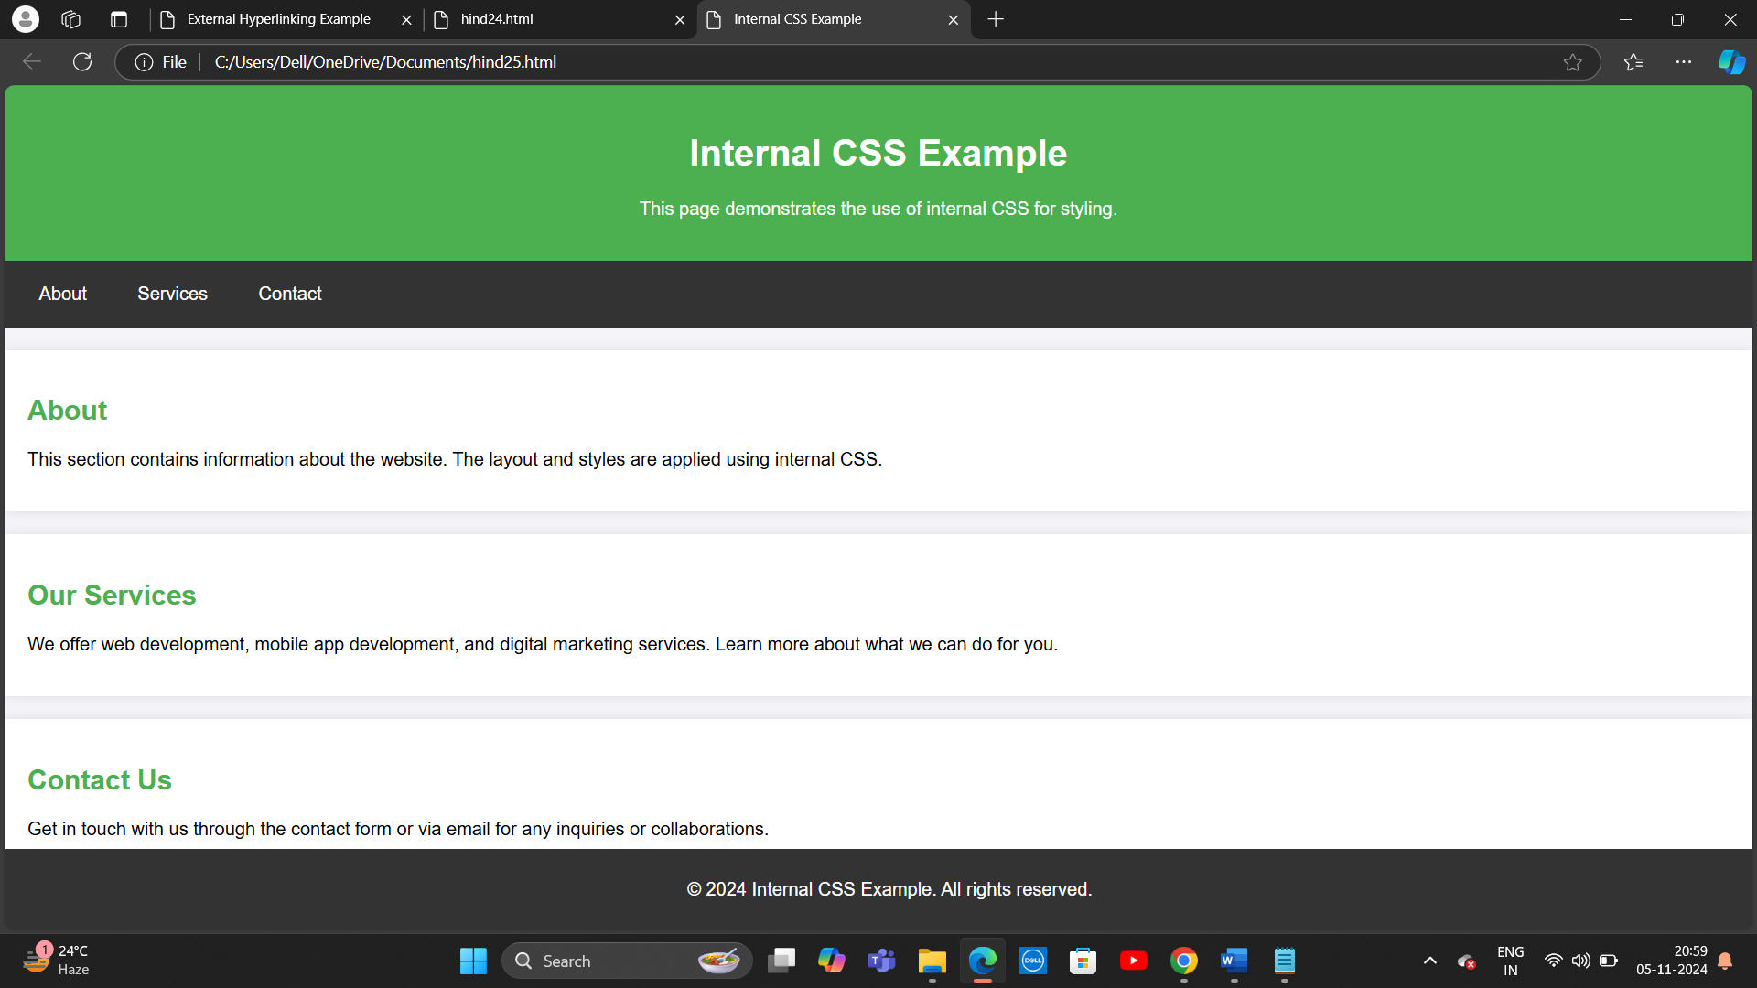

26. Write code to show Inline CSS with HTML code.

<!DOCTYPE html>

<html lang="en">

<head>

<meta charset="UTF-8">

<meta name="viewport" content="width=device-width, initial-scale=1.0">

<title>Inline CSS Example</title>

</head>

<body style="font-family: Arial, sans-serif; background-color: #f4f4f9;">

<!-- Header Section with Inline CSS -->

<header style="background-color: #4CAF50; color: white; padding: 20px; text-align: center;">

<h1>Inline CSS Example</h1>

<p>This page demonstrates the use of inline CSS for styling specific elements.</p>

</header>

<!-- Navigation Bar with Inline CSS -->

<nav style="background-color: #333; padding: 10px;">

<a href="#about" style="color: white; text-decoration: none; padding: 10px 20px; display: inline-block;">About</a>

<a href="#services" style="color: white; text-decoration: none; padding: 10px 20px; display: inline-block;">Services</a>

<a href="#contact" style="color: white; text-decoration: none; padding: 10px 20px; display: inline-block;">Contact</a>

</nav>

<!-- About Section with Inline CSS -->

<section id="about" style="padding: 20px; margin: 20px 0; background-color: white; box-shadow: 0 0 10px rgba(0, 0, 0, 0.1);">

<h2 style="color: #4CAF50;">About</h2>

<p>This section contains information about the website. The layout and styles are applied using inline CSS.</p>

</section>

<!-- Services Section with Inline CSS -->

<section id="services" style="padding: 20px; margin: 20px 0; background-color: white; box-shadow: 0 0 10px rgba(0, 0, 0, 0.1);">

<h2 style="color: #4CAF50;">Our Services</h2>

<p>We offer web development, mobile app development, and digital marketing services. Learn more about what we can do for you.</p>

</section>

<!-- Contact Section with Inline CSS -->

<section id="contact" style="padding: 20px; margin: 20px 0; background-color: white; box-shadow: 0 0 10px rgba(0, 0, 0, 0.1);">

<h2 style="color: #4CAF50;">Contact Us</h2>

<p>Get in touch with us through the contact form or via email for any inquiries or collaborations.</p>

</section>

<!-- Footer Section with Inline CSS -->

<footer style="background-color: #333; color: white; text-align: center; padding: 10px;">

<p>&copy; 2024 Inline CSS Example. All rights reserved.</p>

</footer>

</body>

</html>

